4730 Colby Avenue  Everett  WA  98203  Phone: (425) 385-4023  Fax: (425) 385-4022

August 19, 2011

To the Benefit Eligible Employees of Everett Public Schools:

The Trustees of the Everett School Employee Benefit Trust want to provide you with an update on changes in our state health care funding and how these changes will likely impact each of us. You may recall in early April we sent you information regarding possible legislative actions to the funding for K-12 education employees. Many of you responded by contacting your representative. One of the outcomes of the legislative session was the freezing of K-12 health benefit allocations for two years.

As Trustees of the Everett School Employee Benefit Trust, we are in the initial stages of reviewing health, dental and insurance benefit options for our membership for 2012. In light of the legislature’s health benefits funding level, some important issues are becoming increasingly apparent that result in significant challenges:

- We estimate a 15% increase next year in the cost for maintaining current benefits across all plans, due to the continually increasing costs for medical and dental coverage.
- This year the Trust expended 2.9 million dollars from the reserves to minimize large increases in employee contributions. The Trust does not have the reserves to sustain this level of assistance into the coming year.

Due to the flat level of funding from the state, the impending increases of coverage costs and the inability of the Trust to continue to offset large increases in benefit costs, we anticipate that in the coming year each employee will be required either to choose a plan which contains substantial increases in per-employee contributions, choose a plan which reduces current benefit levels, choose a plan which increases deductibles and copays, or some combination of these three options. While none of these options are desirable, your Trustees remain committed to providing benefit eligible employees with plans that offer a wide a range of coverage, costs and benefits from which to choose.

For many years your Benefit Trust has provided a higher level of benefits at lower per-employee costs than most other school districts across the state. The Benefit Trust is continuing to review coverage options and will be in contact with you after the beginning of the school year to provide follow up information. We remain sincerely committed to your health, wellness and benefits.

Sincerely,
The Trustees of the Everett School Employee Benefit Trust
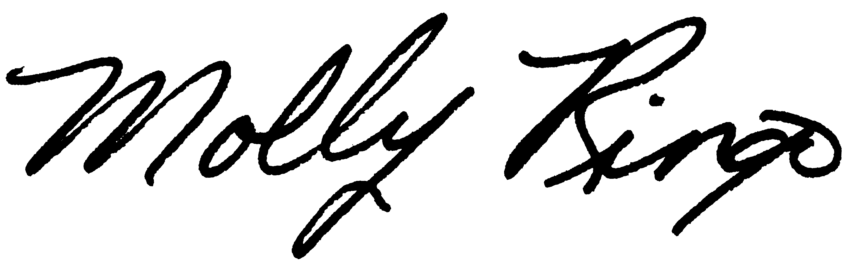
Everett School Employee Benefit Trustees

Attachments

